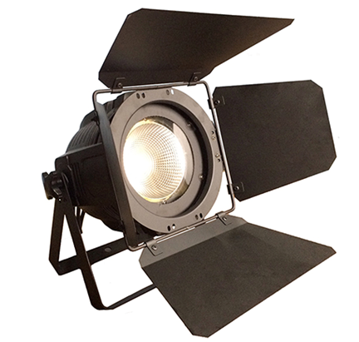

200W COB LED PAR Light
Contents
1. General information
2. Safety instructions
3. Performance trait and technical specifications
4. Digital display
5. DMX Chart
6. Cleaning and maintenance
1. General information
1. Congratulations, you have just purchased one of the most reliable 200W COB LED PAR Light on the market today.
2. Please read and understand the instructions in this manual carefully and thoroughly before attempting to operate this unit. These instructions contain important information regarding safety during use and maintenance.
Notice:
As part of our ongoing commitment to continuous products update, our company will keep the right to improve this products, the information in this menu may be changed in the future, our company reserve the right to change the data without any advises.

Unpacking:
1. Thank you for purchasing our company products. Every product has been thoroughly tested and has been shipped in perfect operating condition.
2. Carefully check the shipping carton for damage that may have occurred during shipping. If the carton appears to be damaged, carefully inspect your fixture for damage and be sure all accessories necessary to operate the fixture have arrived intact. In the event damage has been found or parts are missing, please contact our customer support team for further instructions.
3. Inside the box you should find: the 200W COB LED PAR Light and this user manual.
2. Safety instructions
Notice: To guarantee proper and consistent operation, it is important to follow the guidelines in this manual. Our company will not accept responsibility for damages resulting from the misuse of this fixture due to the disregard of the information printed in this manual.
1. Please check the voltage, frequency data of power supply system is suitable for the mentioned on the 200W COB LED PAR Light. Please do avoid the different voltage between them and burn the light.
2. Do not attempt to operate this fixture if the power cord has become damaged or frayed.
3. Never open this fixture while in use.
4. Never look directly into the light source. You risk injury to your retina, which may induce blindness.
5. Please be aware that damages caused by modifications to the device are not subject to warranty.
3. Performance trait and technical specifications
1. Flicker free
2. Built-in programs
3. LED Light Source: 1pcs 200 watt COB LED lamp(WW/CW)
4. Lamp average life time: 50,000 hours
5. DMX Channel: 5 channel
6. Control Mode: Auto, Master/Slave, DMX512, software(connect to computer), sound control
7. Dimmer: 100% linearly adjustable
8. Strobe: 0~25F.P.S
9. Voltage: AC100-240V 50/60Hz
10. Power: 200W
11. Working Environment: indoor -20℃- 40℃
12. IP Rate: IP20
13. Size(cm): 30 * 22 * 32
14. Weight(kg): 3
4.Digital display
Display | Mode | Function
Addr | DMX address 001-512 | DMX address
Chan | 5CH | Channel selection
MASL | MAST | The host
 | SLAV | From the machine
 | Auto | Automatic mode
Auto | Speed | Since the walking speed
 | Dimmer | Dimmer
Soun | On/Off | Acoustic medallion
Sens | 0-100 | color fading
 | Color | The color menu
Colo | Dimmer | Dimmer
 | Strobe | Strobe
 | Dimmer | Dimmer
 | Strobe | Strobe
 | W | 0-255
MAnu | W | 0-255
 | W | 0-255
 | W | 0-255
BlAc | No/Yes | Signal black field switch selection
LED | On/Off | According to the switch
Disp | up/down | According to reversing
Test | Test | The test of lamps and lanterns
Temp | Temp | Temperature display

5. DMX Chart
5CH mode
CHANNEL | DMX VALUE | FUNCTION
CH1 | 0-255 | Dimmer
CH2 | 0-255 | 6500K
CH3 | 0-255 | 3200K
CH4 | 0-255 | CTO
CH5 | 0-255 | Strobe

6. Cleaning and maintenance
1. It is absolutely essential that the fixture is kept clean and that dust, dirt and smoke-fluid residues must not build up on or within the fixture.
2. Regular cleaning will not only ensure the maximum light-output, but will also allow the fixture to function reliably throughout its life.
3. A soft lint-free cloth moistened with any good glass cleaning fluid is recommended, under no circumstances should alcohol solvents be used!
CAUTION!
Be careful with your operations. With a dangerous voltage you can suffer a dangerous electric shock when touching the wires!
Electric shock when touching the wires!
This device has left our premises in absolutely perfect condition. InEveryipr

